File Structure Overview

The following documents the use of the 00_setup.py script for use with the current version of Seis-Suite.

In order to run 00_setup.py either the Linux bash shell or Mac OSX terminal is required. Currently there is no support for Windows users. The user must choose the parent folder where all input raw waveforms and metadata files will be placed, as well as where all output files are saved to once processing has been completed. The following diagram represents the file structure produced:

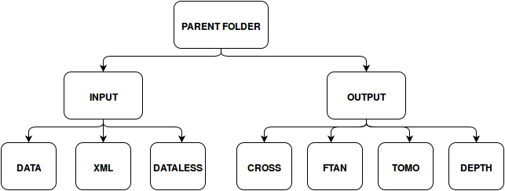
All MSEED raw waveform files can be placed in whatever order, and with whatever file name you like into the folder DATA in the INPUT folder. The metadata files associated with the raw waveforms, in either station XML or dataless SEED format are placed in the XML and DATALESS directories respectively. If a raw waveform file has no metadata placed in these two directories, but others are functioning, then the ambient noise applications will skip that station or those stations accordingly.

